**Guidance for 2D-XRD Modelling**

Yibin Jiang, Zikun Ren, ChengWang

This guidance is for 2D-XRD-Modelling, which is a series of matlab codes (matlab 2013a) to simulate Powder X-ray Diffraction (PXRD) patterns of 2D materials with finite size. The basic theoretical method is a complete integrating method in real space (CIREAL). This code uses the Numerical Integration Toolbox in matlab. Depending on the parameters and simulated crystal structures, the time cost for the calculation can be from several seconds to several hours.

1. **Preparing Crystal Structures**

The first step for simulation is to read in a crystal structure for simulation. This code can read in ***cif*** files, which can be exported by **Material Studio**, a common software for building crystal structures. The interlayer axis should also be set as c axis. It is recommended to read in a structure with **primary unit cell**, which will significantly save simulation time.

1. **Setting Parameters for Simulation**

After preparing the ***cif*** files, open ***MODELONE.m*** and run. One should set the size of simulated crystals, corresponding X-ray wavelength, and the diffraction angle range and corresponding angle interval through the following windows:

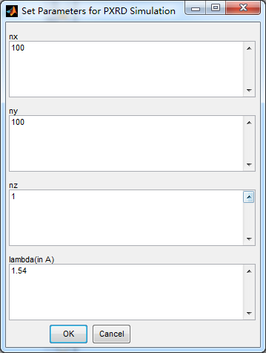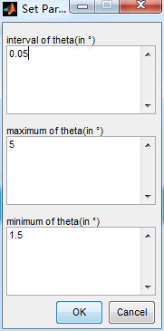

It is safe to set large deta_theta intervals to save time, as the code will automatically set additional points close to the peak positions to make sure it is not missed.

Then two important parameters should be set, k_a and k_b. These two parameters describe the projection of interlayer shifting on the a and b axes. The shifting vector along the c axis can thus be expressed as , where is vertical to the a-b plane.

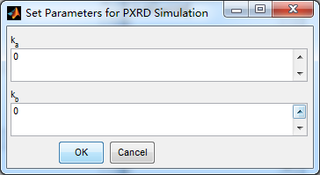

For simulation of crystals stacked the in eclipsed mode, we can simply set k_a and k_b to zeros.

For simulation of crystals stacked in staggered mode, one should set k_a and k_b respectively.

1. **Examples for Eclipsed and Staggered Crystals**

Here we demonstrate the simulation process through an example MOF, Zr-TCBPE by building the crystal structure in eclipsed model or staggered model. These two structure files can be found in the EXAMPLE file.

For the eclipsed model, we read in the structure file, ***2D Zr-TCBPE-eclipsed.cif*** , and set the following parameters:

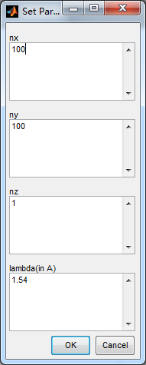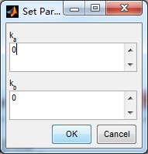

Then chooce the file ***2D Zr-TCBPE-eclipsed.cif***.

The predicted PXRD pattern can show up within minutes. One can change *nz* to explore the relationship between PXRD patterns and number of layers.

For the staggered model, we read in the structure file, ***2D Zr-TCBPE-staggered.cif*** , and in this structure we find the primary unit cell and build the interlayer axis as :

So the parameters should be set as :

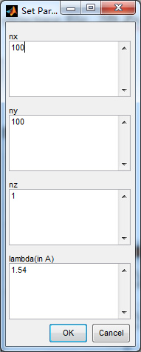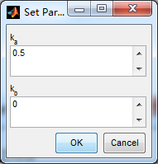

Then we can obtain the PXRD pattern. One can change *nz* to explore the relationship between PXRD patterns and the number of layer.